DOCUMENTATION, ASSESSMENT AND PLANNING RECORD
Context: |  |  | Date: 15th October, 2024  Child: Vance (1.5 years old)  Educator: Dikshya  Setting: Indoor Morning play in the Animal Puzzle Corner
DOCUMENTATION
Documentation: Jotting
9:30 am: Vance walks to the animal puzzle corner and looks carefully at the various animal pieces on the shelf. He selects a lion puzzle piece and inspects it closely before placing it onto the puzzle board.
9:31 am: Vance takes a moment to study the piece he placed. He then starts to mimic the sound of a lion, saying, “Roar!”
9:32 am: Noticing me near him, Vance pauses and watches as she demonstrates the lion's roar. He leans in to listen more closely and tries to imitate her sound, repeating, “Roar!” with enthusiasm.
9:33 am: Vance continues to explore other puzzle pieces, carefully selecting a monkey next. He imitates the monkey’s sound by saying, “Ooh ooh, ah ah!”, while looking at me to see my reaction.
9:34 am: Vance giggles as he stands next to Dikshya, who encourages him by mimicking the monkey sound back to him. They share a smile, and Vance appears engaged, eager to continue exploring the sounds of the animals.

ASSESSMENT
Each portion of the documentation above is to be reflected on and identified domains, milestones and dispositions must be linked to where the skill was demonstrated in the observation and referenced.
Domains |  |  |  | Milestones |  | Dispositions
Cognitive: Vance engaged in problem-solving by fitting puzzle pieces together, showing an understanding of shapes.  Language: Vance communicated verbally by mimicking animal sounds and engaging with the educator.  Social: Vance interacted positively with Dikshya by responding to her sounds and smiling at her encouragement. |  |  |  | Vance displayed curiosity about animal sounds and interactions (ACECQA,2018).  Vance showed confidence in expressing himself with sounds (ACECQA,2018).  Vance displayed a sense of belonging through interaction and play(ACECQA,2018). |  | Vance displayed higher imagination skills by interpreting his animal and trying to learn about it. The sounds of other animals which he did not know.  Vance displayed confidence and communication by expressing his thoughts about animals by expression to the educator.
LEARNING and CURRICULUM
Each portion of the documentation is to be analysed for learning that is occurring and the curriculum areas the children are engaging in
Learning |  |  |  |  | Curriculum Areas
Language Development: Vance developed his language skills by mimicking animal sounds and engaging in verbal play.  Cognitive Skills: Vance displayed cognitive skills by matching puzzle pieces and developing problem-solving strategies.  Social Skills: Vance practised social interaction through shared play and communication with the educator. |  |  |  |  | Fine motor development: Activities focusing on hand-eye coordination and grip.  Social and Emotional Development: Vance encouraged positive interactions between educators and developed a sense of belonging.  Art and creative expression: Vance used puzzles to communicate ideas and feelings (ACARA, 2017).
THEORY and FRAMEWORKS
Development and Education Theory |  |  |  |  | Early Years Learning Framework Principles, Practices, Outcomes
Fine motor development: Activities focusing on hand-eye coordination and grip.  Social and Emotional Development: Vance encouraged positive interactions between educators and developed a sense of belonging.  Art and creative expression: Vance used puzzles to communicate ideas and feelings (ACARA, 2017). |  |  |  |  | Principles: Secure, Respectful, and Reciprocal Relationships; High Expectations and Equity.  Practices: Responsiveness to Children, Holistic approaches, and Learning through Play.  Outcomes: Vance is an effective communicator and a confident learner.
PEDAGOGICAL SKILLS AND KNOWLEDGE
Each portion of the documentation is to be analysed for pedagogical skills and knowledge demonstrated by the educators.
Play-based Pedagogies |  | Teaching Strategies |  |  | EYLF Educator Evidence |  | Child Development
Facilitating interactions while encouraging turn-taking and sound imitation. |  | Encouragement  Scaffolding  Reflective dialogue  Facilitation of Social Interaction |  |  | This aligns with the EYLF outcome of Children are Connected with and Contribute to Their World.  The educator’s interaction with Vance asking questions from emotions and scaffolding his thought demonstrates responsiveness to interests and developmental stage. |  | Emotional: Vance is connected with his educator emotionally as he comes and sits near the educator and sits on her lap.  Vance's cognitive development is evident as he can mimic the sounds of animals to Dikshya.
PLANNING
Objective for future holistic learning and development
To enhance Vance's language development, social skills, cognitive skills, and fine motor skills through play-based experiences focusing on animals and sounds.
Learning Experience
Learning experience name |  | Animal Sounds exploration
Experience rationale |  | Keeping Vance's interest in animals and mimicking sounds in mind, this activity will further enhance his language skills, cognitive development, and social interaction.
Development and learning goal: |  | To develop Vance’s ability to articulate full sentences, enhance his vocabulary, and foster cooperative play through group activities centred around animals.
Experience outline: |  | Vance and his peers will explore various animal toys and picture books, providing opportunities for them to identify each animal, learn about their habitats, and imitate their sounds. The activity will culminate in a group storytelling session where children can share their favourite animals and sounds.
A list of materials required with photo(s): |  | • Animal figurines  • Picture cards of animals  • Storybooks about animals  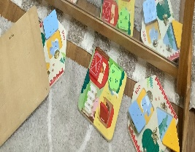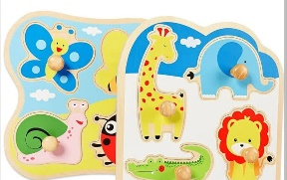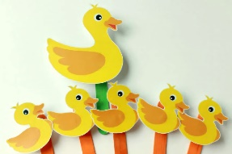
EYLF child evidence links |  | Children Are Effective Communicators: Vance’s participation in discussions and storytelling promotes communication skills.
Implementation plan | Introduction | Gathered Vance and his peers in a circle. Introduce various animal figurines and ask open-ended questions about what they see.
 | Body | Children explored the figurines and picture cards. Educators also encouraged them to make sounds, mimic animals, and use descriptive language about what they know. Also, Provided an animal sound machine to enhance their understanding and keep engagement high.
 | Conclusion | I gathered the children to share their favourite animals and perform the sounds they had learned. By reinforce new vocabulary and celebrate their contributions to the group story
 | Engagement questions | - What sounds do lions make?  - Can you show us how a monkey moves?  - Which animal is your favourite? Why?  - What other animal sounds do you know?  - Where do you think animals live?
ACTING and DOING
Play pedagogies |  | Creative play, Guided Play, Social Play
Teaching strategies |  | Intentional teaching, Scaffolding, Co-Constructing, Modelling
EYLF links |  | Children are effective communicators and a confident learner.
Child development |  | Language Development, Fine Motor Skills, Social Skills, Cognitive development
Documentation and/or digital evidence of implementation, acting and doing |  | 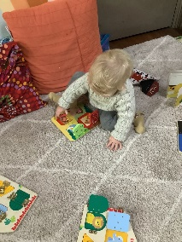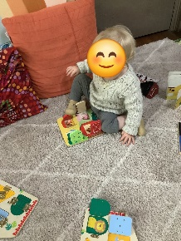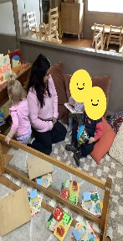
REFLECTING and REVIEWING
How did the children respond? Did they achieve the learning objective? Were there any unexpected outcomes? What was your role? How did you support and teach the children? Would you do anything differently? Where to next?
During the "Animal Sounds Safari Experience," children, including Vance, engaged enthusiastically as they explored animal figurines and picture books. They actively participated in storytelling by mimicking animal sounds and sharing their favourite animals. Vance showed confidence, used new vocabulary, and articulated full sentences, fulfilling the learning objectives of enhancing articulation, vocabulary, and cooperative play.
Remarkably, some children took on leadership roles, guiding peers in demonstrating animal sounds and actions and fostering a supportive atmosphere. The educator effectively facilitated discussions and modelled behaviours.
For future activities, I plan to introduce videos and movement-based tasks to enrich learning further. Incorporating arts and crafts will also support role-play and language development, while ongoing observation will help tailor activities to the children’s interests.

